European Union (EU) is an international organization comprising 28 European countries and governing common economic, social, and security policies. Originally confined to western Europe, the EU undertook a robust expansion into central and eastern Europe in the early 21st century. The EU was created by the Maastricht Treaty, which entered into force on November 1, 1993. The treaty was designed to enhance European political and economic integration by creating a single currency (the euro), a unified foreign and security policy, and common citizenship rights and by advancing cooperation in the areas of immigration, asylum, and judicial affairs. The EU was awarded the Nobel Prize for Peace in 2012, in recognition of the organization’s efforts to promote peace and democracy in Europe.

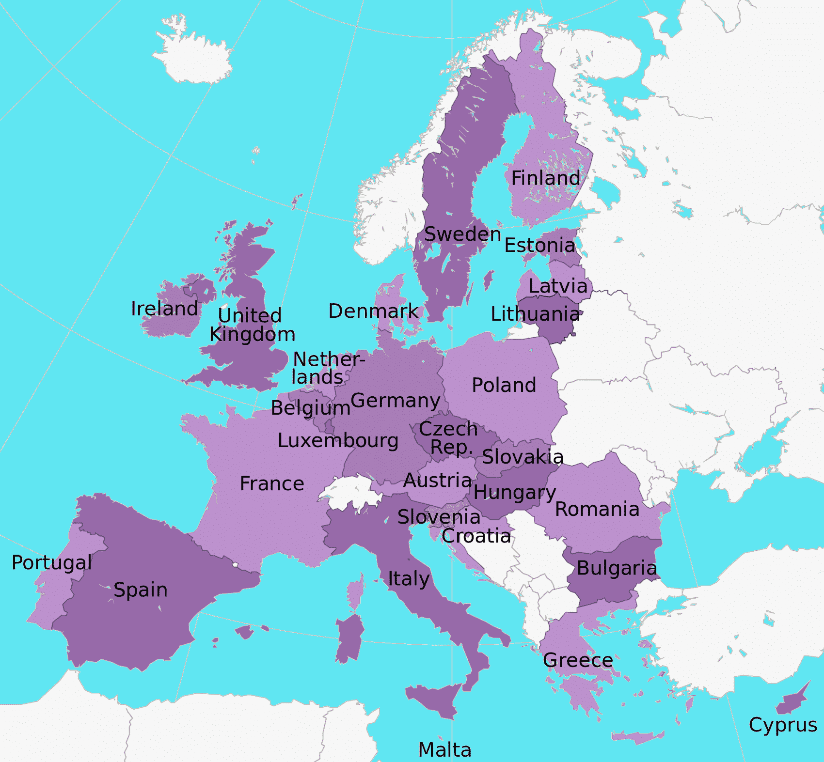

International Governments

- World War I began in 1914. The United States entered in 1917. Why didn’t the United States enter sooner?

- World War II began in 1939. The United States did not enter until 1941. Why did the United States enter sooner?

- Did “staying out” of foreign wars protect the United States? Why or why not?

- In 1945, 50 nations of the world met and formed the United Nations (UN).
- Why was the UN formed?
- What is its main purpose/mission?

- Where was it written and where is it based? What does this show?
- What other international governmental or military alliance do you know about?

- What other issues could be solved better with an international approach?

What powers do governments have? | What powers do citizens have?

Where are these powers derived from?

Agenda:
Day 5

Essential Questions:
- How does free trade encourage world peace?
- Where do governments derive their power from?

- “Do Now” - Constitution Day
- Isolationism v Free Trade
- The European Union - https://europa.eu/european-union/index_en
- http://gametheory101.com/courses/international-relations-101/the-mcdonalds-peace-theory/
- Where is power derived from?
- “Closure” - does globalization promote individual freedoms? Why or why not?
- HW - Country Packet

Preamble:
We the people of the United States, in order to form a more perfect union, establish justice, insure domestic tranquility, provide for the common defense, promote the general welfare, and secure the blessings of liberty to ourselves and our posterity, do ordain and establish this Constitution for the United States of America.

